There you are, in the air somewhere between your home country and the Summer University. Destination: two unforgettable weeks. That’s what the organizers told you, what your friends who have had previous AEGEE experiences told you and why you applied. And then you start to worry a little: what if the people won’t like you? What if you will not make any friends? Fortunately, the other participants turned out to be just like me: exited to make new friends. So socializing went easier than I thought, especially with the icebreaking games the organizers had planned for us!
I went on a travel Summer University, and the first stop was: Valladolid. In a few days we discovered most of the history of Valladolid. Most foreigners don’t know Valladolid (frankly I didn’t either before applying), but thanks to the touristic guide (who spoke English!!! Yes, this is exceptional) I now know that Valladolid used to be the capital city and it even has the oldest University of Spain. Furthermore it has many interesting museums, buildings and churches, it is really worth a visit. After four days we left Valladolid, in a cloudy and painful morning after a night that we will always remember as Sexy Tequila Night (if we would remember anything at all). We could directly implement our knowledge of Spanish the organizers taught us: ¿Quieres follar? Contigo no, ¡bicho! Also, that keeping track of how many people are making out in one night is too much work when you have passed the 10. We traveled to the small village Peñafiel we discovered the charm of a non-globalized old village, with its particular Plaza del Coso and a beautiful Castle with a spectacular view. We also discovered that old traditions of a population may go against our own ideas, when we got told about the traditional bull fights in Spain.
We also travelled to Rioseco, where we got a big surprise: for the first time in a week we could sleep in a real bed and eat real, handmade food, made with love by all the participants for the European Night! There we had one of the best days (and nights!) of the SU: we could show our wild side during a morning of canoeing and cycling, our intellectual side by a visit to the old mill and our dark side has been unchained after dinner, during the European Night where we found out that trying to drink from each bottle on the same night is not a good idea, even worse is to play “I have never” and revealing all your darkest secrets without being able to remember it the next day.
In Barcelona we have been welcomed by new organizers that had set up a fresh dinner for us! Barcelona is a big city, which we explored by playing games! We have had a Gymkhana all along the passage de Gracia where there are many works of Gaudì of which we found out curiosities and noticed little particular things that usually aren’t mentioned in touristic guides. We also entered the Sagrada Familia, where the pleasant voice of the audio-guide has led us under the column of this epic construction. We have been shown The Gothic Cathedral through the history of Enrichetta, she was a thief of children, which was brightly performed by our creative organizers in a horror night with candles.
In Barcelona we have also enjoyed the beach and the sun, when the weather finally decided to let us. The beach of Sitges was definitely worth the visit! We finished visiting the city with a bike city tour, where we visited the wonderful Parc de la Ciutadella with its nice fontain. We also made a group picture with “Barcelona’s dildo”, a long blue building which actually looks like a dildo. We discovered the nightlife and high class clubs of Barcelona where a shots cost €10, but fortunately you could get out and in of the club very easily with a stamp and on the beach some random guys sold beer for €1. We also found out that you were not special at all for paying 1€ for that beer, and you would have been a dumbass if you actually paid the 3€ he initially asked for that beer. I personally found out that cheering for the Netherlands when they make a goal in a pub full of Argentineans is not a good idea.
We got lessons about the culture of Catalunia and they have been very instructive. We finally know how to insult each other in Catalán (ruuuuuuc!) and we tasted the liquor Melody (a liquor made with Catalan cream) with brioche. Speaking about food, when the organizers prepared us an original delicious paella everybody agreed that it has been the best gift they could give us!
But these are all just separate events and I now understand what they mean when they say that the whole is greater than the sum of its parts. The thing we all liked probably the most is that we became one big family, that cares for each other when we are drunk, holds each other’s hair when we throw up, blows up each other’s air mattresses, carries each other’s suitcases and is happy every morning to be woken up with loud music because that means that another awesome day is starting. One of the organizers announced that we should bring a big suitcase, because we would not have enough space to bring back home all the stories and memories we made. He was definitely right.
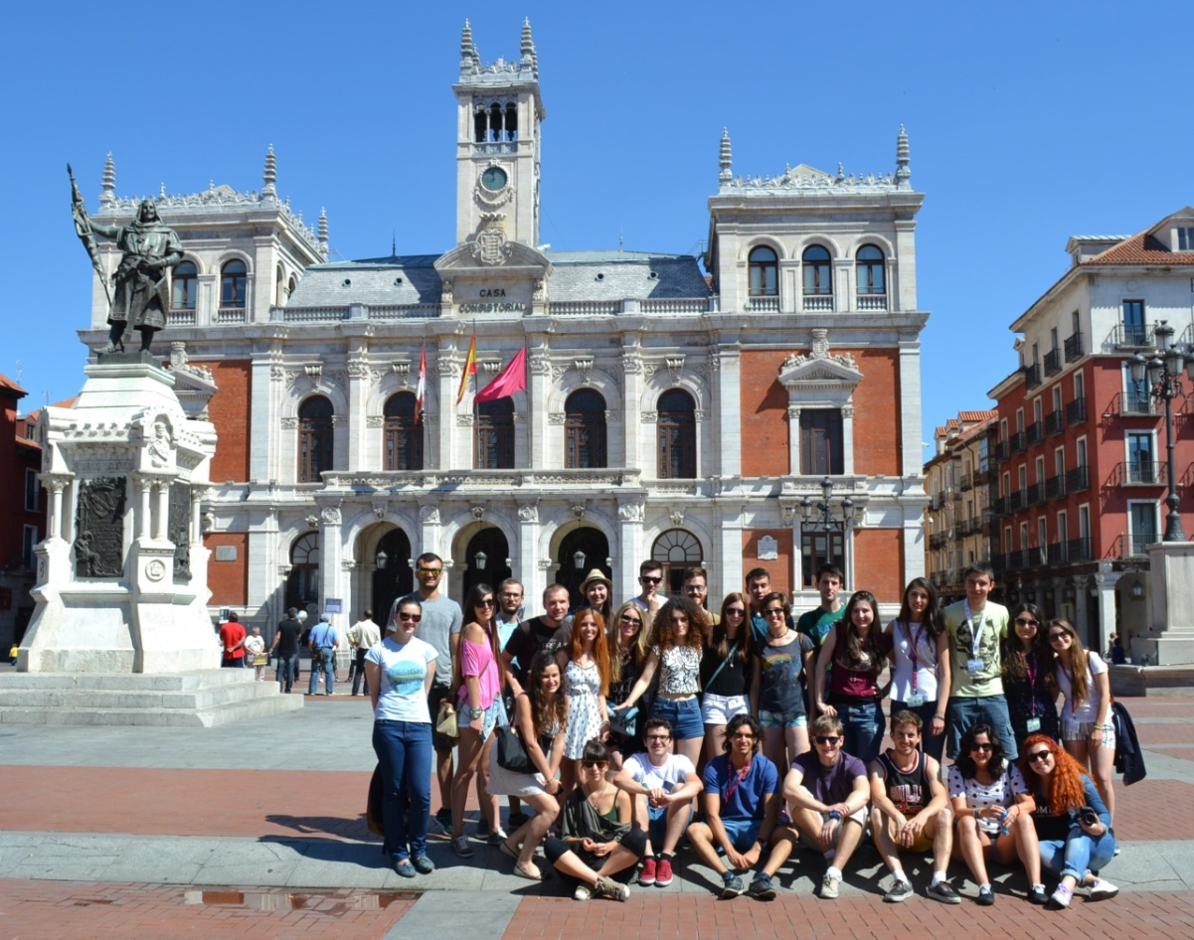
Group picture in Valladolid, at Plaza Mallor
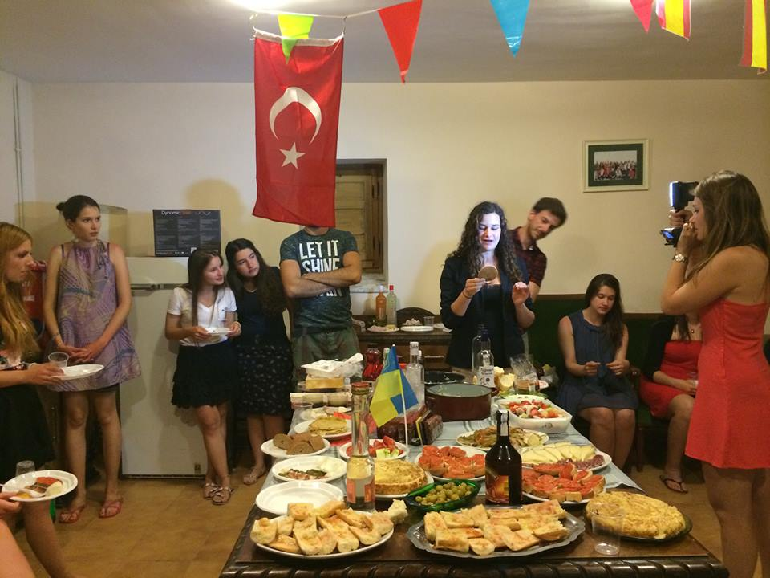
Me introducing the Stroopwafel on the European Night
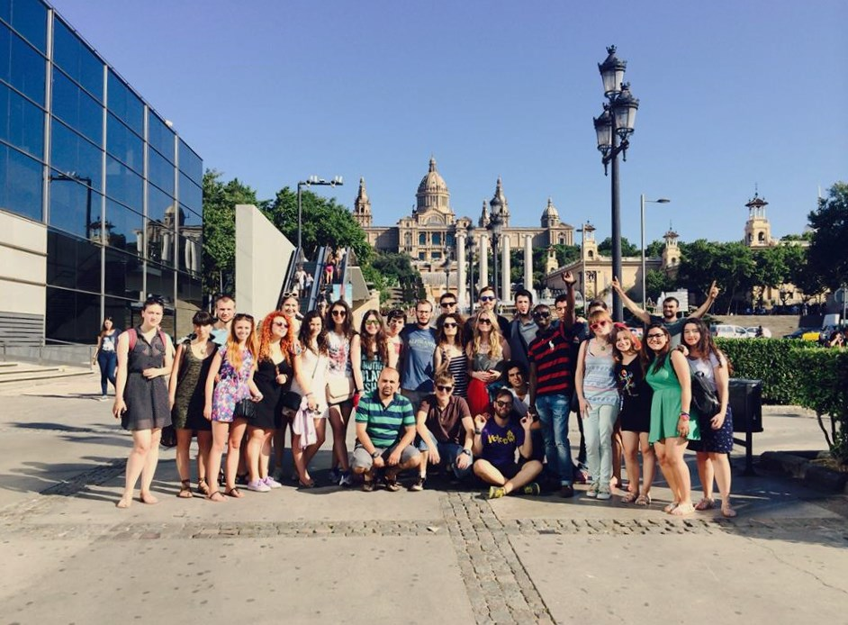Group picture in Barcelona, at the Museu d’Art de Cataluña

